

**A Project Report On**

ON

**“Pharmacy Management System”**

IS SUBMITTED TO

SANT GADGE BABA AMRAVATI UNIVERSITY

IN THE PARTIAL FULFILLMENT OF THE DEGREE OF

**BACHELORS OF ENGINEERING**

**IN**

**INFORMATION TECHNOLOGY**

BY

**Mr. Rutik Yogesh Ekre**

Under the Guidance of

**Prof. G. D. Govindwar**

.

**DEPARTMENT OF INFORMATION TECHNOLOGY**

**SIPNA COLLEGE OF ENGINEERING AND TECHNOLOGY, AMRAVATI**

**(AN ISO 9001:20015 CERTIFIED INSTITUTE)**

**SANT GADGE BABA AMRAVATI UNIVERSITY, AMRAVATI**

**2021-2022**

**Sipna College of Engineering & Technology, Amravati.**

**Department of Information Technology**

**CERTIFICATE**

This is to certify that **Mr. Rutik Yogesh Ekre** has satisfactorily completed the Project work towards the **Bachelor of Engineering Degree** of Sant Gadge Baba Amravati University, Amravati, in Information Technology discipline on the topic entitled **“Pharmacy Management System”**, during the academic year 2021-22 under my supervision and guidance.

**Date:**

**Prof. G. D. Govindwar**

**Teacher Signature**

**Acknowledgement**

A moment of pause, to express a deep gratitude to several individuals, without whom this project could not have been completed. We feel immense pleasure to express deep sense of gratitude and indebtedness to our guide **Prof. G. D. Govindwar**, for constant encouragement and noble guidance.

We express our sincere thanks to **Dr. V. S. Gulhane**, Head, Department of Information Technology and the other staff members of the department for their kind co-operation.

We express our sincere thanks to **Dr. S. M. Kherde**, Principal, Sipna College of Engineering & Technology for his valuable guidance. We also express my sincere thanks to the library staff members of the college.

Last but not the least we are thankful to our friends and parents whose best wishes are always with us.

**Rutik Yogesh Ekre**

**Name of Student**

**Abstract**

The purpose of this Pharmacy Management System project is to improve the maintenance and manipulation of the drugs in the medicals. The pharmacy management system will be used to minimize the time and resource by maintaining the details of the drug systematically so that the data can be used in possible quickest time. While the resource which is minimized are workforce, money, papers, etc. The system is user-friendly and will help the pharmacist. This Pharmacy Management System will reduce the burden on pharmacist and will make the system efficient by providing the more accurate details about drugs in the medical.

Pharmacists can use the Pharmacy Management System program to help them methodically manage their pharmacies. When a medicine’s name is input, the Pharmacy Management System can help by providing details about the medicine. A computer displays information about the medicine, such as its dosage and expiration date. In large medical stores, manually handling the specifics of all the drugs becomes very tough. We can keep track of all the medicines by using this pharmacy management system. It is updated with new information as new medicines are introduced, and it includes an expiration date, stock left, price of medicine as well as a search option for searching specific medicine. When we complete the name of a medicine, it displays the medicine’s details. To make this system, Visual Studio with Python, Flask (Web framework), HTML, CSS, Bootstrap and JavaScript was used. The SQL database was created with MySQL.

**Table of Contents**

|  |  |  |
| --- | --- | --- |
| **Sr. No.** | **Title** | **Page No.** |
| **1** | **Introduction** | **01** |
| **2** | **Technology Used** | **02** |
| **3** | **Software Used** | **02** |
| **4** | **Screenshots** | **04-06** |
| **5** | **Database Tables** | **07-08** |
| **6** | **Future Scope of Project** | **09** |
| **7** | **Result** | **10** |
| **8** | **Conclusion** | **11** |
|  | **References** | **-12** |

1. **Introduction**

The "Pharmacy Management System" has been developed to override the problems prevailing in the practicing manual system. This project is supported to eliminate and in some cases reduce the hardships faced by this existing system. Moreover this system is designed for the particular need of the company to carry out operations in a smooth and effective manner. The application is reduced as much as possible to avoid errors while entering the data. It also provides error message while entering invalid data. No formal knowledge is needed for the user to use this system. Thus by this all it proves it is user-friendly. Pharmacy Management System, as described above, can lead to error free, secure, reliable and fast management system. It can assist the user to concentrate on their other activities rather to concentrate on the record keeping. Thus it will help organization in better utilization of resources.

Every organization, whether big or small, has challenges to overcome and managing the information of Medicines, Pharmacy, Company, Sells, Inventory. Every Pharmacy Management System has different Pharmacy needs, therefore we can design this system according to their needs.

The project source code is available on :-

[rutikekre/pharmacy_management_system (github.com)](https://github.com/rutikekre/pharmacy_management_system)

1. **Technologies Used**

* Python 3.6 or Above
* Flask (Python Web Framework)
* PyMysql (Python Module to perform operations on database)
* HTML
* CSS
* Bootstrap
* JavaScript
* MySQL

1. **Software Used**
   * Development :- VS Code
   * Server :- Xampp
   * Web Browser – Microsoft Edge, Google Chrome, Firefox
2. **ER- Diagram**

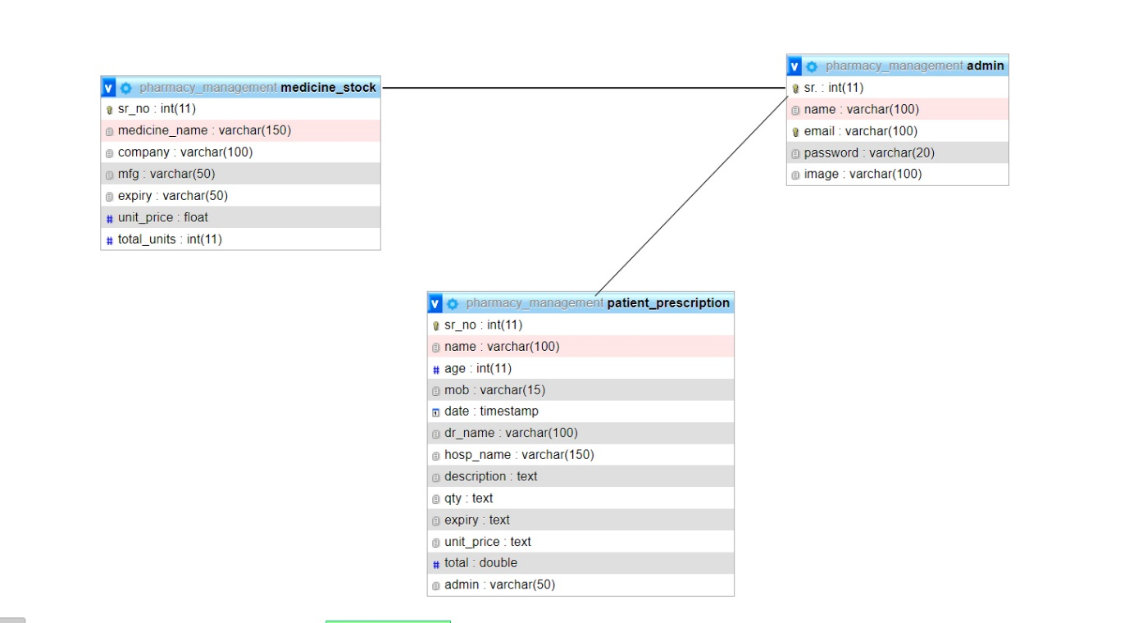

1. **Screenshots**

**5.1 Login Page**

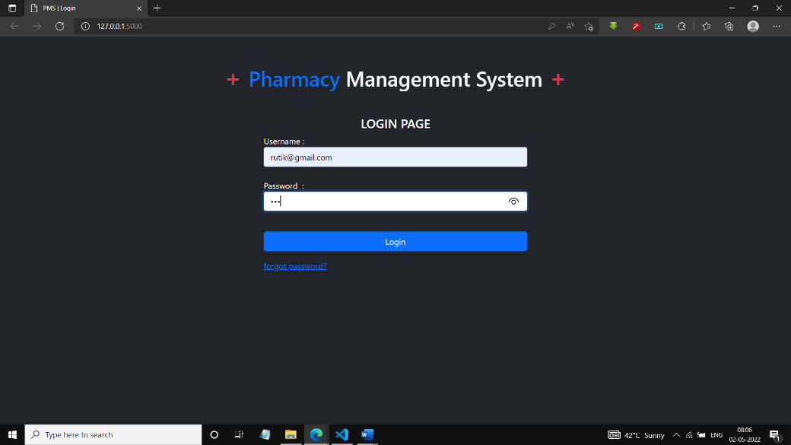

This is the first screen of the project. Admin can log in and use all the features of the program. If login fails because of any reason this page show the alert box.

**5.2 Admin Home**

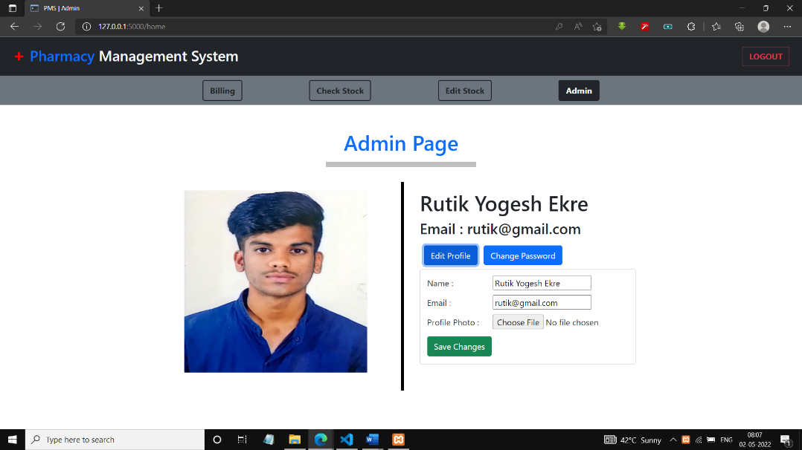

After the successful login admin will redirect to this page, which show his/ her profile. This page provides operations such as changing password, editing name, email id and profile picture.

* 1. **Check Stock**

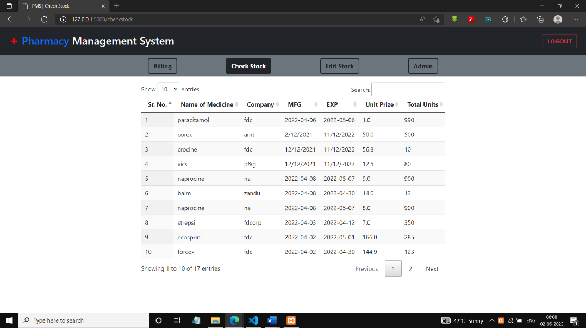

This page shows details about stock available in the pharmacy. It also has search option so that we can search items. It shows details such as Name of Medicine, Company, Manufacturing Date, Expiry Date, Unit Price and Total Units Available in pharmacy.

**5.4 Edit Stock**

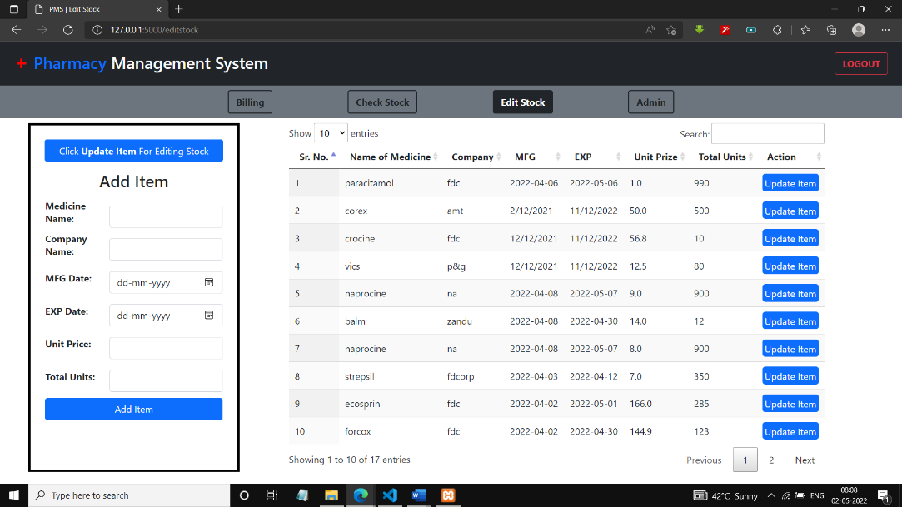

This page provides options for Adding the new Item in Stock and Updating the pre-existing item in the stock. We Can edit Medicine Name, Company name, manufacturing date, expiry date, price and total units.

**5.5 Billing**

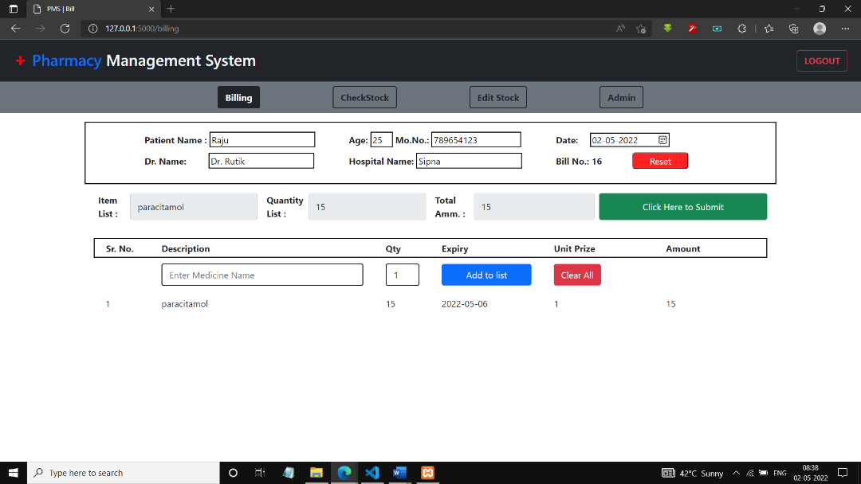

This page provide interface to create a bill. It provides various fields for taking patient details such as name, age, mobile no., doctor name, hospital name etc. And fields like description, quantity, Expiry date, unit price and Total Amount.

**5.6 PrintBill**

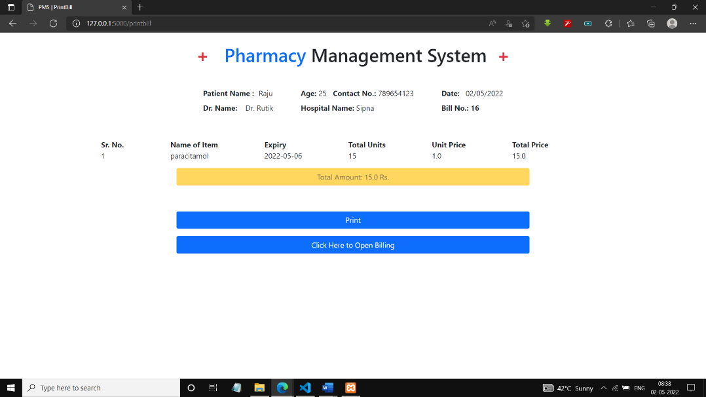

After the successful bill submission a final bill will be showed on screen along with this a print bill option is provided to print physical copy.

1. **Database Tables**

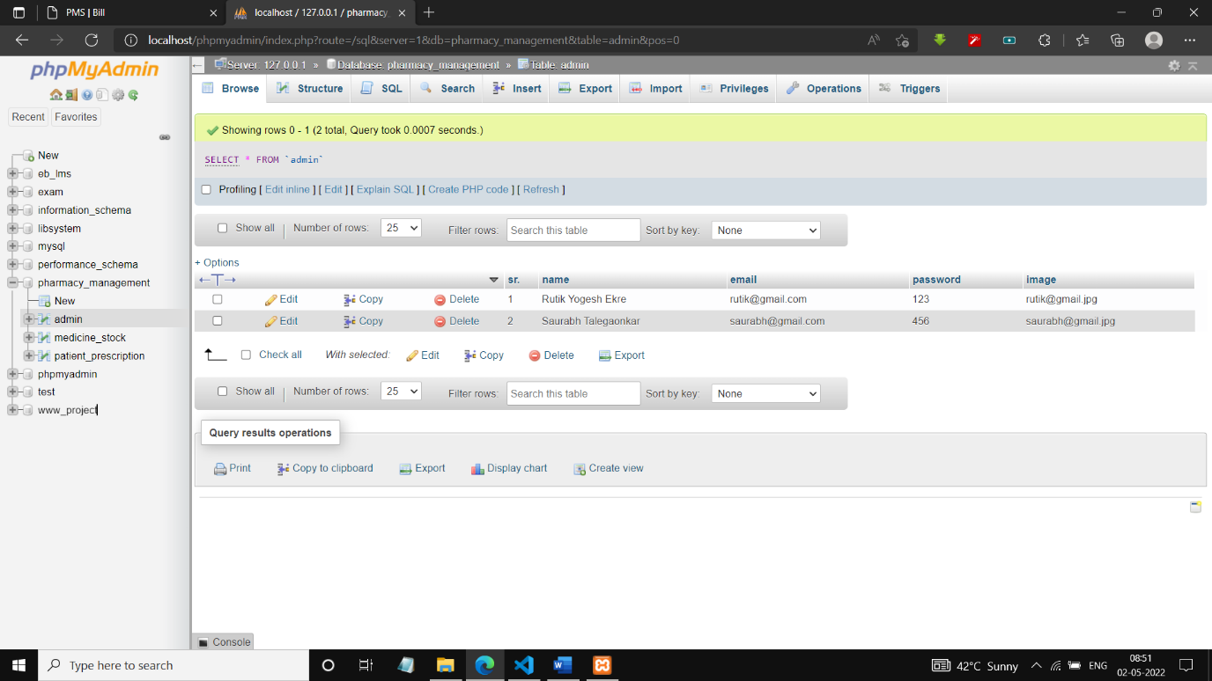

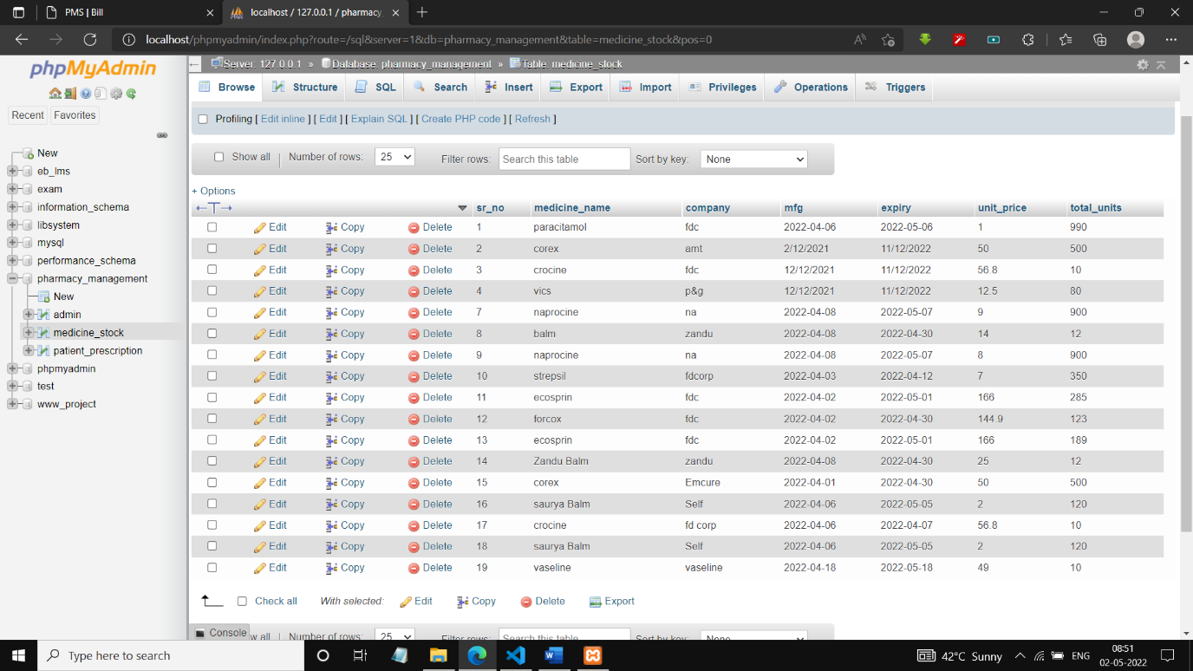

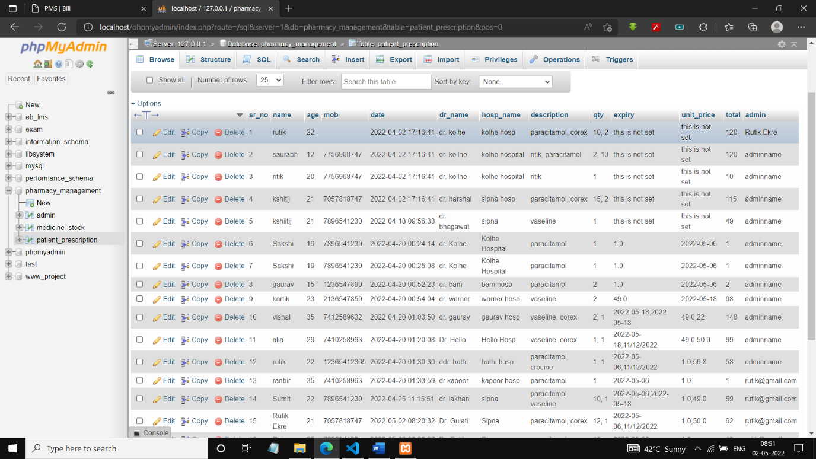

1. **Result**

**Advantages :-**

* It helps to store and maintain the patients data.
* It helps to analyze stock available in pharmacy.
* It helps to recognize the expired items.
* Stock Maintenance in pharmacy becomes easy.

**Disadvantages :-**

* Current version is not uploaded on online server.

1. **Conclusion**

Finally, in the Pharmacy Management System, we have a system where the user takes the prescription from the doctor is read by the pharmacist and he will bring medicines accordingly. Pharmacist can create or print bills with the help this Pharmacy Management System. Also, the patient’s data like name, mobile number, address, doctor’s name along with prescription, price of item, expiry date is also stored in database.

This Pharmacy Management System also helps Pharmacist to manage the medicine stock. He/ She can add the new medicine into the database, also can update the previously available items. Field for medical stock storage given this project are name of the medicine, quantity available, manufacturing date, expiry date and unit price of each item.

This Pharmacy Management System helps Pharmacies to manage their data securely and makes their tasks easier. It also provide easy to use user interface which saves the time and handling customers becomes easy with the help of this project

**10. Future Scope of the Project**

In a nutshell, it can be summarized that the future scope of the project circles around maintaining information regarding:

* We can give more advance software for Pharmacy Management System including more facilities
* We will host the platform on online servers to make it accessible worldwide
* Integrate multiple load balancers to distribute the loads of the system
* Create the master and slave database structure to reduce the overload of the database queries
* Implement the backup mechanism for taking backup of codebase and database on regular basis on different servers

The above mentioned points are the enhancements which can be done to increase the applicability and usage of this project. Here we can maintain the records of Pharmacy and Medicines. Also, as it can be seen now-a-days the players are versatile. i.e. so there is a scope for introducing a method to maintain Pharmacy Management System . Enhancement can be done to maintain all the Pharmacy, Medicines, Stocks, Company, Inventory

**References**

1. Google for problem solving.
2. https://www.github.com/
3. https://www.stackoverflow.com/
4. https://www.w3schools.com/
5. https://www.geeksforgeeks.org/
6. https://www.getbootstrap.com/